Krish holdiays – Online Flight Booking System
Full Stack MERN Project Documentation

- 1. Introduction
- Project Title: Krish holdiays – Explore the world, One Flight at a Time!
- Member: Sathish Kumar S

- 2. Project Overview Purpose
- Krish holdiays is designed to digitize and streamline the entire flight ticket booking process. The system eliminates traditional offline or agent-based booking methods by offering a fast, secure, and user-friendly online platform.
- It provides passengers, airlines, and administrators seamless tools for:
- Real-time flight search
- Seat availability checking
- Ticket booking and cancellation
- User profile management
- Airline management & admin monitoring Krish holdiays aims to:
- Allow users to search flights based on source, destination, date, and airline.
- Provide passengers with a smooth interface for booking, cancelling, and viewing tickets.
- Provide airlines a structured portal to manage flights, schedules, and seat availability.
- Enable administrators to manage flights, users, bookings, and airline approvals.
- Improve workflow efficiency with fast cloud-based access and reduced manual errors.
- Ensure secure & authenticated interactions using a solid MERN architecture. Features
- JWT-based user authentication
- Flight search & filter system
- Real-time seat availability
- Passenger dashboard (bookings, cancellations)
- Airline dashboard (manage flights, schedules, seats)
- Admin panel (manage users, airlines, flights)
- Secure REST API
- Booking history & e-ticket generation

  - Architecture
- Frontend (React.js):
- React with Hooks and Context API
- Axios for API communication
- Bootstrap/Material UI for UI components
- React Router DOM + Protected Routes
- Backend (Node.js + Express.js):
- RESTful API architecture
- Authentication middleware
- Role-based access control (user/airline/admin) Database (MongoDB + Mongoose):
- Collections:
- Users
- Flights
- Bookings
- Airlines
- Schema validation using Mongoose models.

  - Setup Instructions
- Prerequisites
- Node.js (v16+)
- MongoDB / MongoDB Atlas
- Git
- Installation Steps
- Clone the repository
- Install dependencies in both client & server folders
- npm install
- Create .env in backend:
- MONGO_DB="mongodb_connection_string"
- JWT_SECRET="your_secret_key"
- Start both frontend & backend
- Frontend: npm start
- Backend: nodemon index.js

  - Folder Structure
- Client (React):
- /src/components – UI Components
- /src/pages – Flight pages, booking pages
- /src/context – Global state management
- /src/utils – Helper functions
- Server (Node.js):
- /routes – API endpoints
- /controllers – Business logic
- /models – Mongoose Schemas
- /middleware – Auth & security

  - Running the Application
- Frontend: npm start
- Backend: nodemon index.js

  - API Documentation
- User APIs
- POST /api/user/register – Create account
- POST /api/user/login – Login user
- GET /api/user/profile – Fetch user profile
- Flight APIs
- GET /api/flight/search – Search flights
- POST /api/flight/add – Add flight (Airline/Admin)
- POST /api/flight/update – Update flight details
- Booking APIs
- POST /api/booking/create – Book ticket
- GET /api/booking/user-bookings – User booking history
- POST /api/booking/cancel – Cancel booking
- Admin APIs
- GET /api/admin/get-airlines – View all airlines
- POST /api/admin/approve-airline – Approve/Reject airline
- GET /api/admin/get-users – View all users
- GET /api/admin/all-bookings – View all bookings

8. Authentication
- JWT-based authentication • Tokens stored in Local Storage
- Role validation:
- User (Passenger)
- Airline
- Admin

- 9. User Interface

• (Add screenshots of UI pages: Flight Search, Booking Page, Dashboard, etc.)

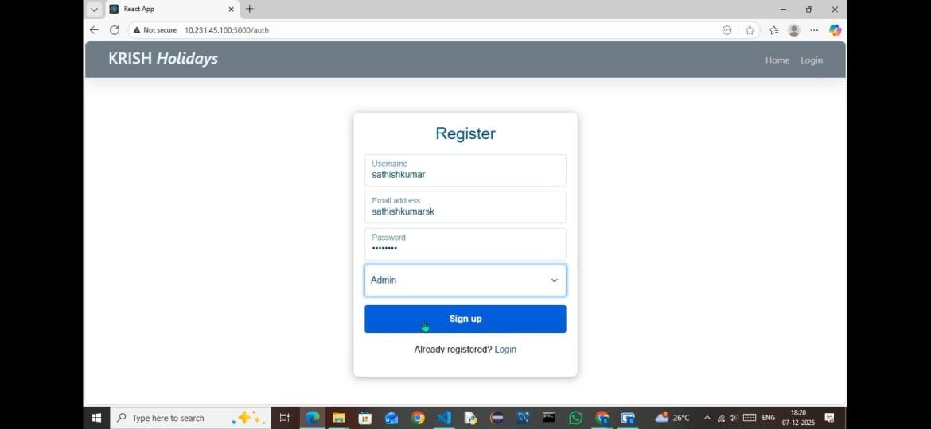
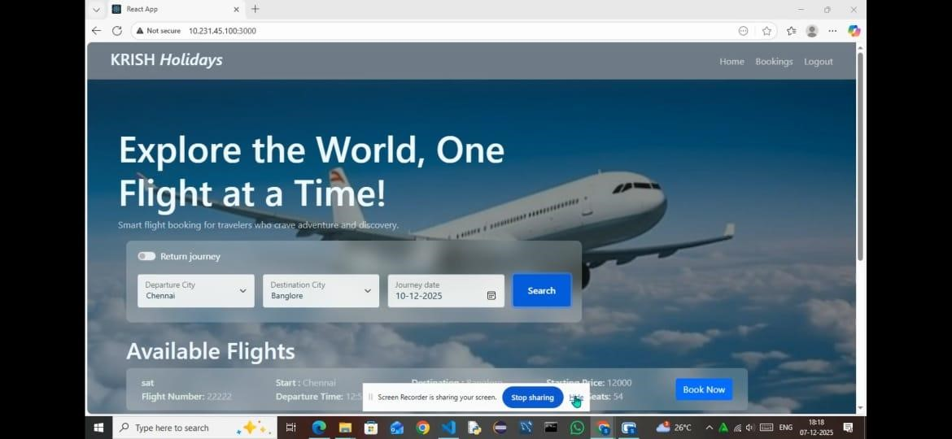

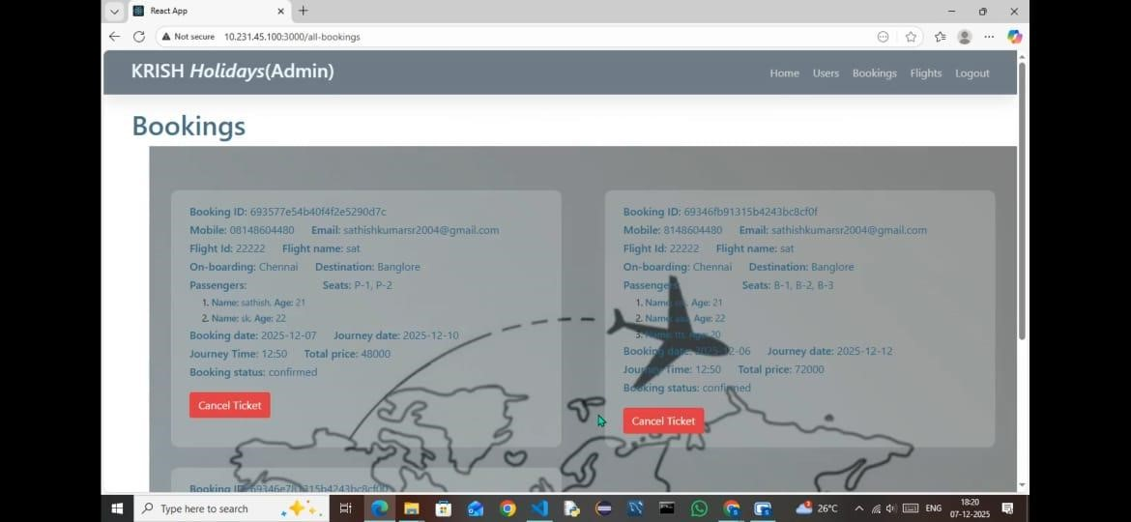

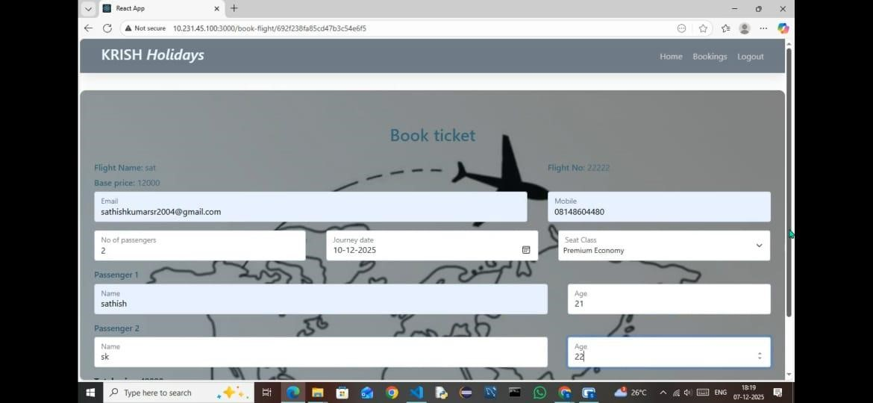

10. Testing
- Manual functional testing
- Endpoint testing with Postman
- JWT authentication testing

11. Screenshots or Demo

• (Attach screenshots or provide demo/video link)

12. Known Issues
- Occasional delay in seat availability update
- Airline dashboard UI improvements needed

13. Future Enhancements
- Add online payment gateway integration
- Add boarding pass QR generation
- Live flight tracking
- Add email/SMS updates for booking & cancellations

